宇成兴助手APP安装教程

Yu Chengxing Assistant APP Installation Tutorial

前言：此版本可兼容M8和M9系列

Note：This version is compatible with M8 and M9 series

1 前往宇成兴官网下载安装包

1 Go to the Yu Chengxing official website to download the installation package

中文网址：[www.ycxbest.com/M960.html](http://www.ycxbest.com/M960.html)

English website：[www.ycxbest.com/en/M960.html](http://www.ycxbest.com/M960.html)

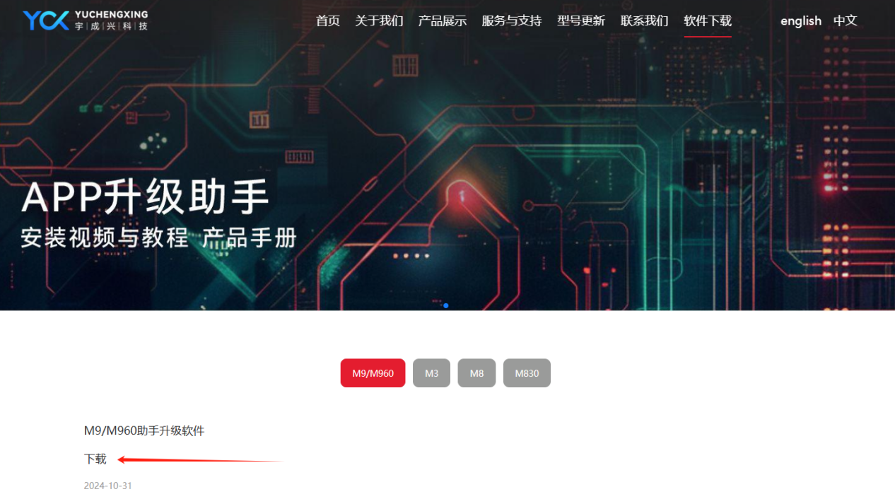

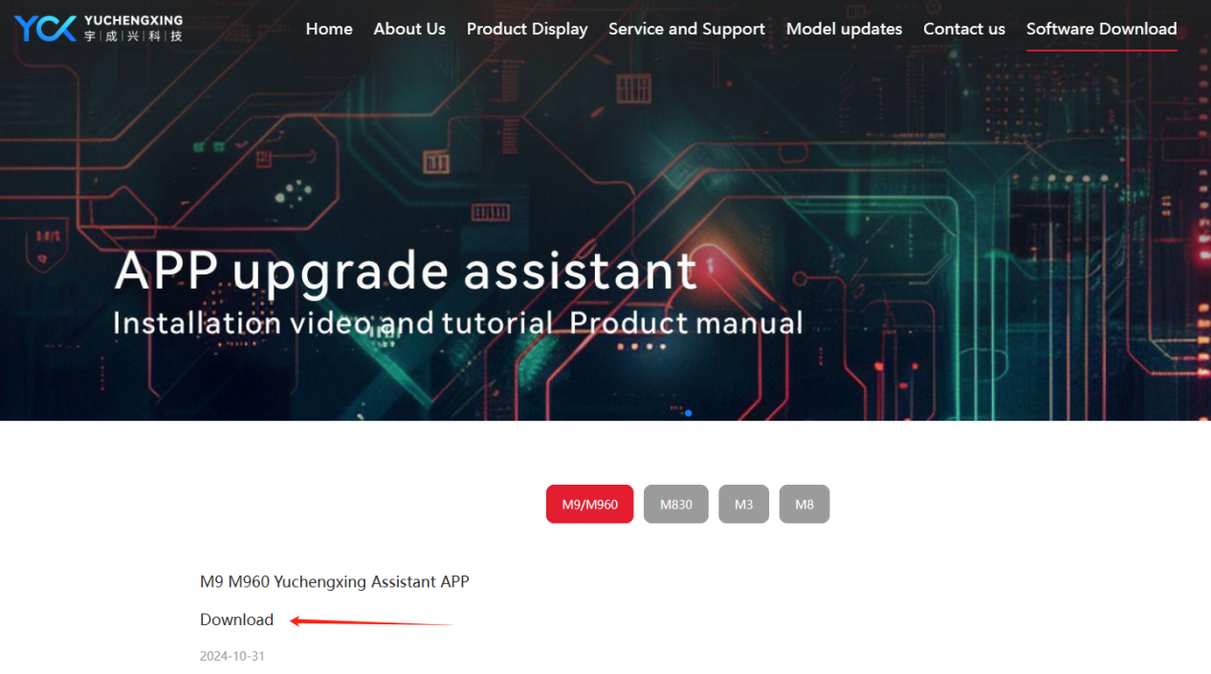

2 开始安装宇成兴助手

2 Install Yu Chengxing Assistant APP

2-1双击打开下载的宇成兴助手应用程序

2-1 Double click to open the downloaded Yuchengxing Assistant application

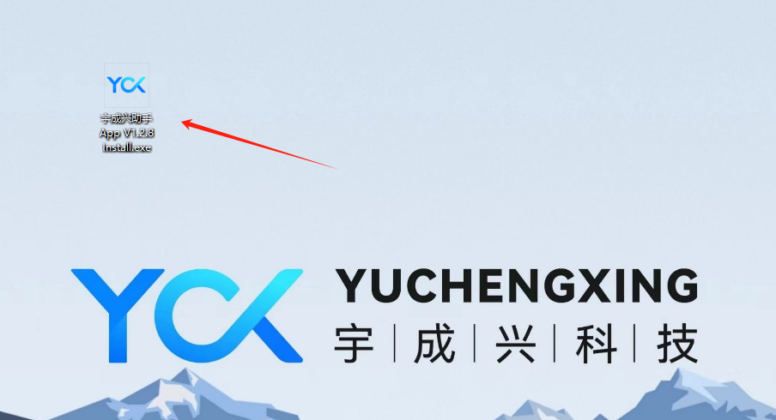

2-2 点击下一步

2-2 Click next

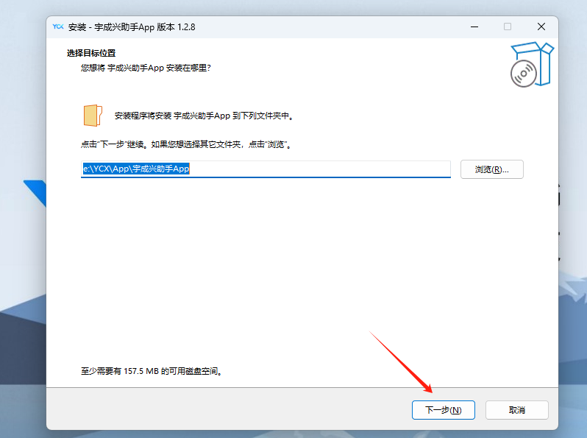

2-3 点击下一步

2-3 Click next

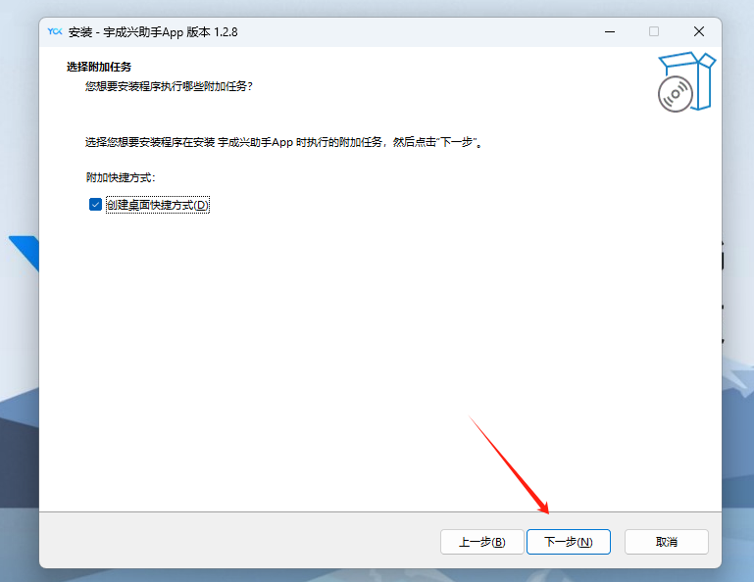

2-4 点击安装

2-4 Click installation

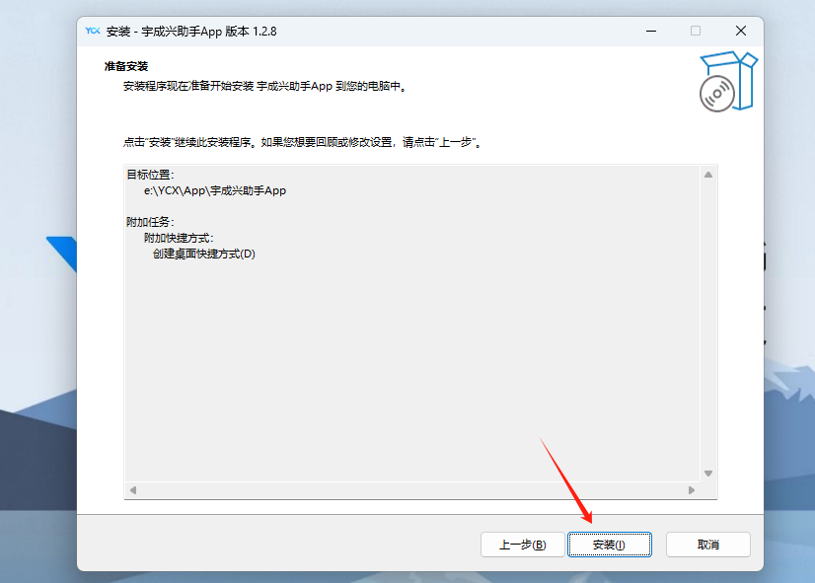

2-5 点击完成

2-5 Click finish

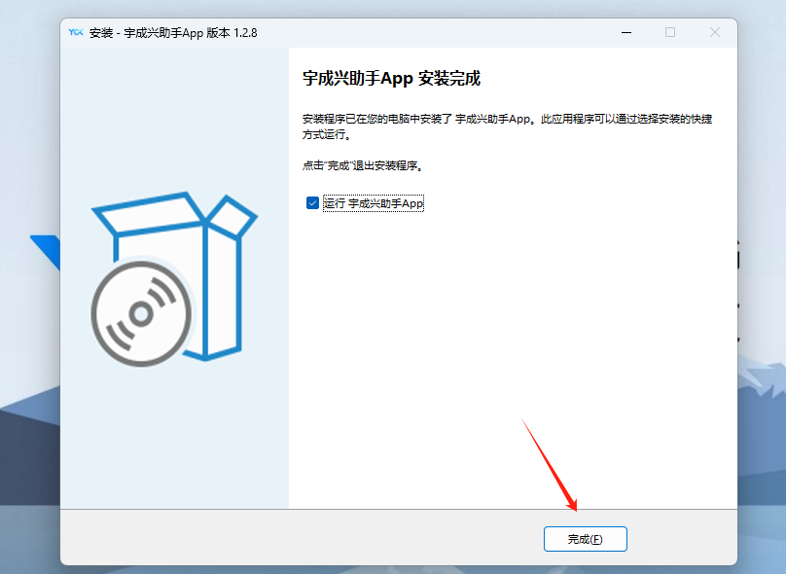

3 开始登录

3 Start logging in

3-1 选择服务器所在国家，默认为中国。

3-1 Select the country where the server is located,default to China

3-2 点击右下角设置，选择升级程序保存在本地的位置，默认为[剩余容量最大盘符]下的[YCX]文件夹

3-2 Click on the settings in the bottom right corner, select the location where the upgrade program is saved locally, and default to the [YCX] folder under the [Maximum Remaining Capacity Drive Letter]

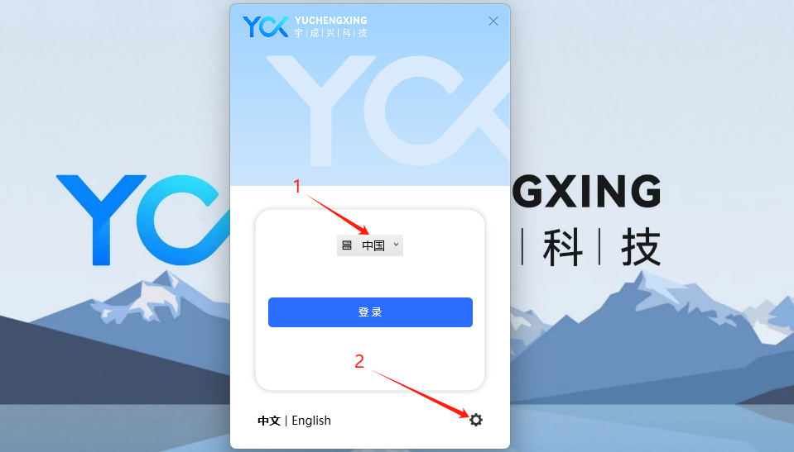

3-3 点击登录

3-3 Click to log in

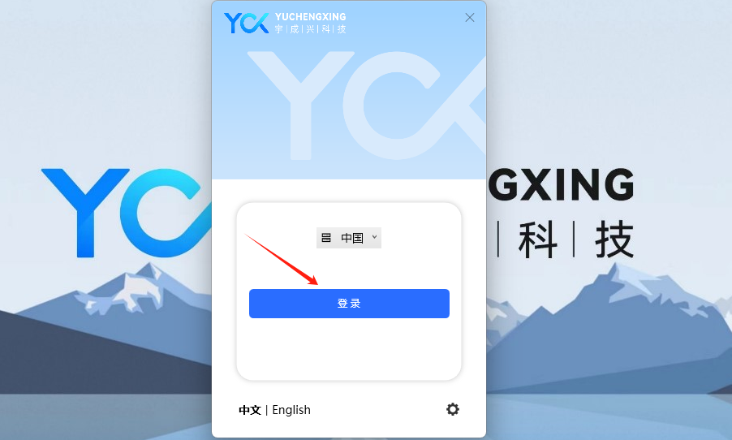

4 升级程序（整个过程不可将盒子关机和断开电脑连接）

4 Upgrade the program(The entire process cannot shut down the box or disconnect the computer connection)

4-1 用type-c连接上需要升级的产品（必须是开机状态下操作），会弹窗提示是否升级，点击确认

4-1 Use type-c to connect the product that need to bu upgraded(Must be operated in power on state),a pop-up window will prompt whether to upgrade,click OK

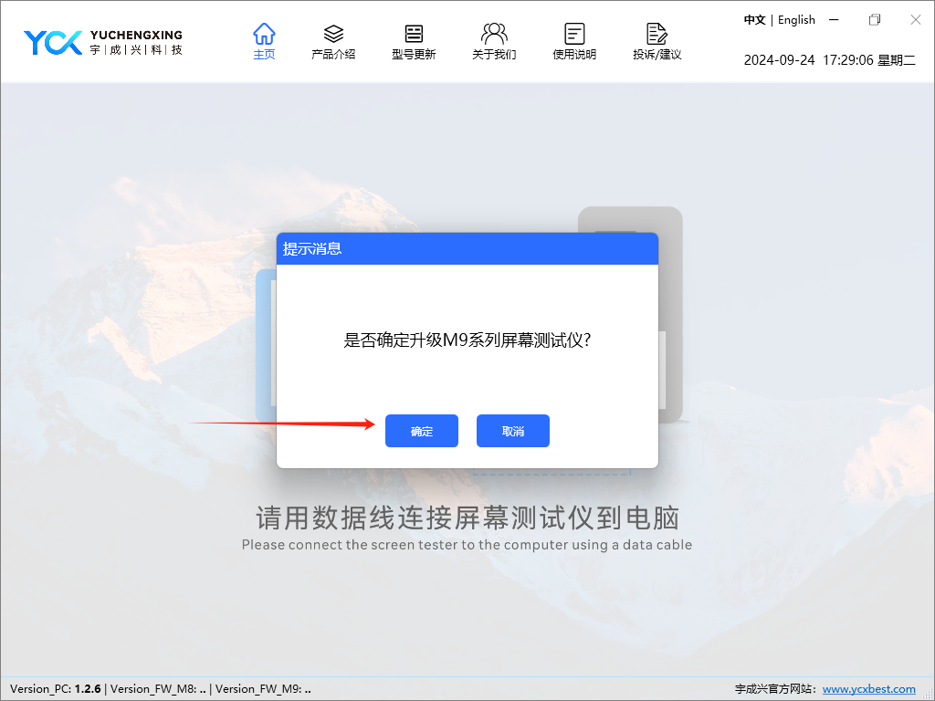

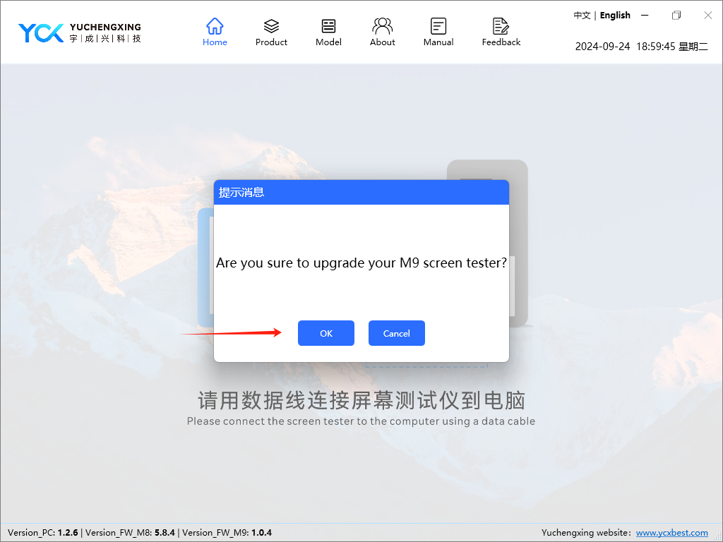

4-2 校验和下载文件

4-2 Verify and download files

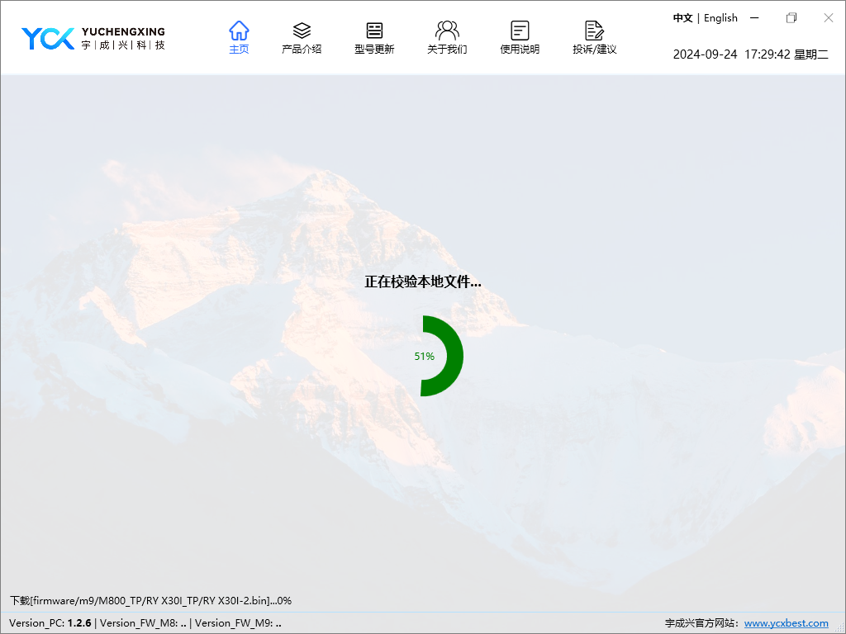

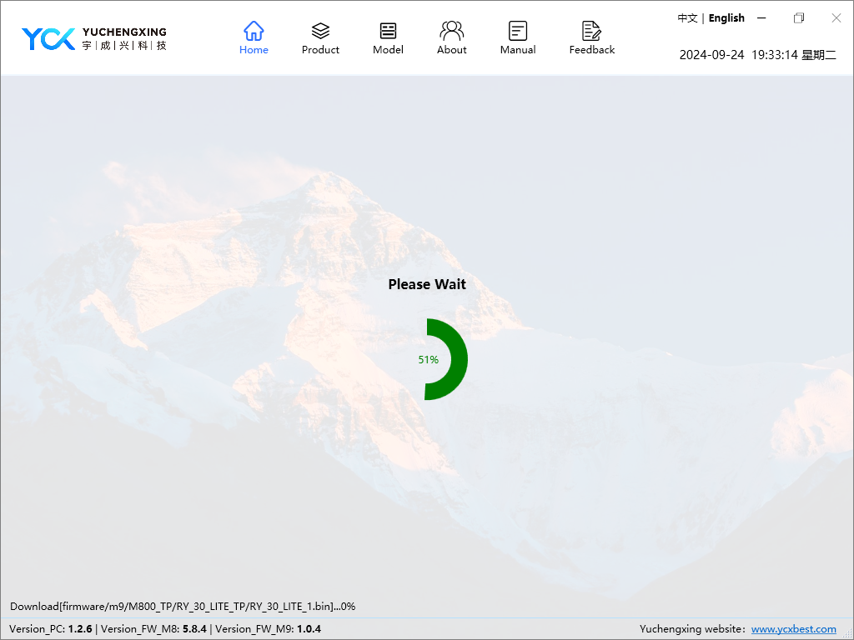

4-3 校验完文件，自动开始升级，更新状态中

4-3 Automatically start upgrading after verify files

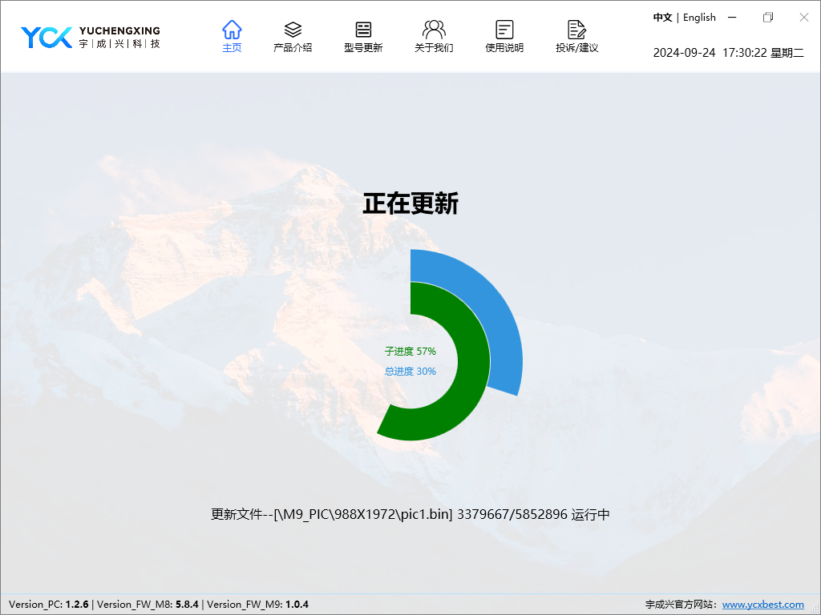

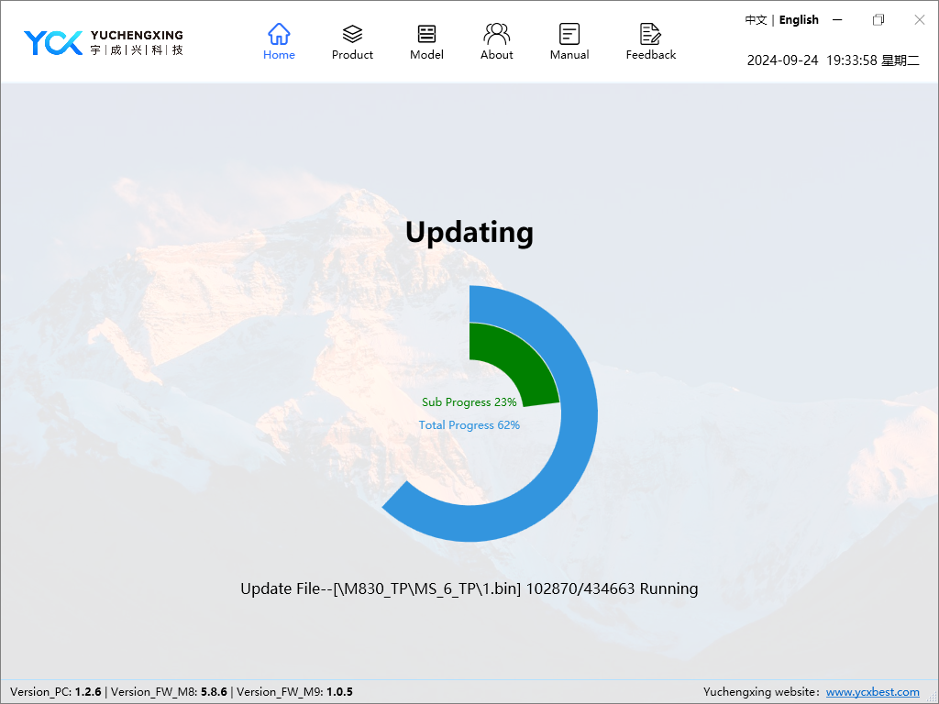

4-4 更新完成

4-4 Update completed

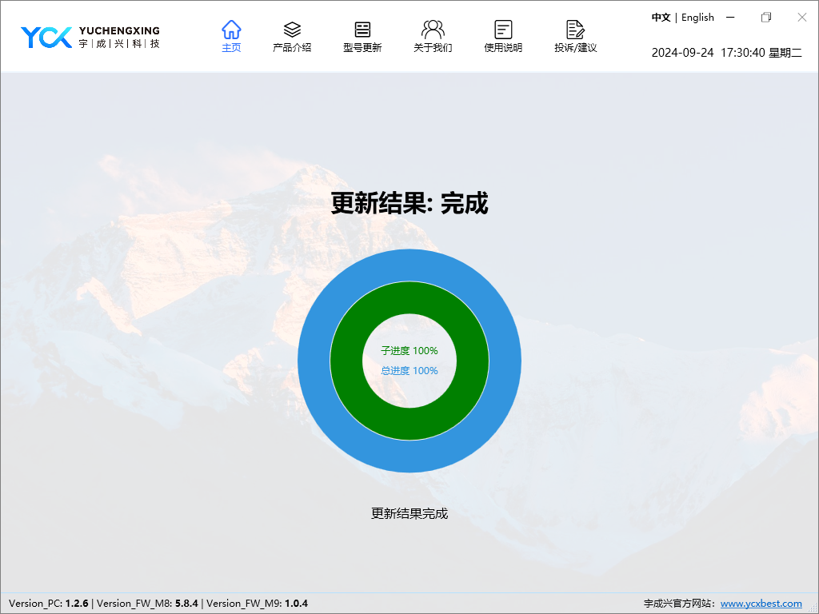

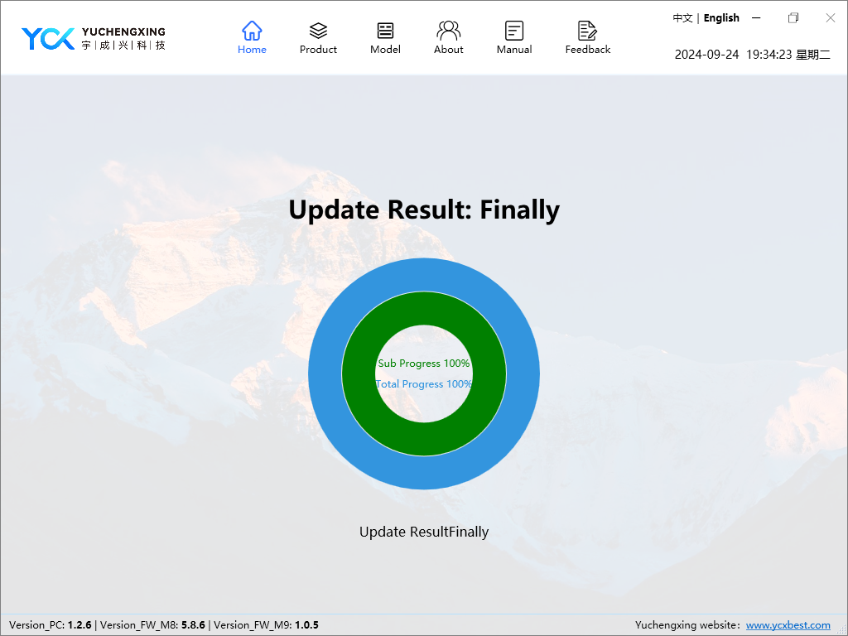

5 更新完成后，请关机重启测试盒

5 After the update is complete, please shut down and restart the test box